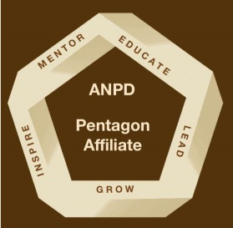
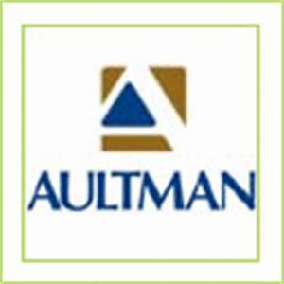
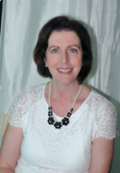
Friday, September 21, 2018
Morrow House Auditorium
Aultman Hospital
2600 Sixth St. S.W. in Canton, OH 44710
9 a.m. – 4 p.m.
Registration opens at 8:30
Cost: $80 includes parking, lunch and handouts
(Pentagon members $50)
Registration online at https://anpdpentagonconference.eventbrite.com
Jointly Provided by

Engaging Your Learners

in Action
Michele Deck, RN, MEd, BSN, LCCE, FACCE

SPEAKER
Michele Deck presents nationally and internationally on innovative teaching methods in the field of health care education and training. She is the recipient of many honors and awards for her creativity, innovation, productivity and exemplary leadership qualities. Honors include ANPD’s prestigious Belinda E. Puetz Award, election to Sigma Theta Tau National Nursing Honor Society, Business Woman of the Year by the National Business Council. She is co-founder and chief executive officer of G.A.M.E.S., a company that specializes in seminars on adult learning and interactive training methods, and Tool Thyme for Trainers, a company which supplies innovative and creative presentation tools for educators worldwide. She has authored twelve books on creative and involving ways to teach adults. She is a past president of Lamaze International and it’s current Accreditation Chair. She served on ANPD’s Education committee and was a member of the Editorial board of the Journal For Nurses in Professional Development for 8 years.

PLANNING COMMITTEE
Debbie Shaffer
Diane Lorenzen
Melanie Morris
Teresa Westerheide-Haller
Cindy Willis

Planners/Speakers have no real or perceived conflict of interest that relates to this presentation.
Direct questions to Melanie Morris at ANPDPentagon@gmail.com

Special Thanks
8:30 a.m. Registration
8:55 a.m. Welcome and Introductions
9:00 a.m. Know White and Her Seven Learners Plus One
10:30 a.m. Break
10:45 a.m. Know White con’t

12:45 p.m. Lunch

1:30 p.m. Spellbinders
2:15 p.m. Break
2:30 p.m. Spellbinders con’t
3:15 p.m. Questions and Evaluation
3:30 p.m. Pentagon Affiliate Meeting
4:00 p.m. CE Certificate Distribution

5.25 CE will be awarded upon successful completion
You must attend the entire program to receive CE Credit

Aultman Hospital is approved as a provider of continuing nursing education by the Ohio Nurses Association, an accredited approver by the American Nurses Credentialing Center’s Commission on Accreditation. (OBN-001-91), (OH-058/3-01-19).

Know White And Her Seven Learners Plus One
Have you ever wondered how to make content memorable for your learners? Noticed that there are several different ways to reinforce important information for your learners? Let "Know" White introduce you to her learners. This session compares eight cartoon characters to the eight frames of mind according to Dr. David Lazear, et al., the recognized experts in multiple intelligences. Assess your learner’s dominant style and plan your teaching method to match it.

Spellbinders: Stories that Create Magic, Inspire, Teach, and Motivate
Stories have been used for thousands of years as a teaching tool. In this session, discover ways to improve your own story telling skills, so that when teaching, your stories can provide a meaningful learning point. This session focuses on increasing the impact of your message by sharing some story telling success secrets that you can apply immediately. Discuss the three voices in which stories can be told and which is most powerful when making a point. Assess your stories and select the most appropriate voice to tell it in: first person, second person, or third person.

Outcomes:
- Analyze story secrets that allow you to get people’s attention and keep it throughout the learning experience.
- Assess your stories and select the most appropriate voice to tell it in: first person, second person, or third person.

Event Schedule

SESSIONS

