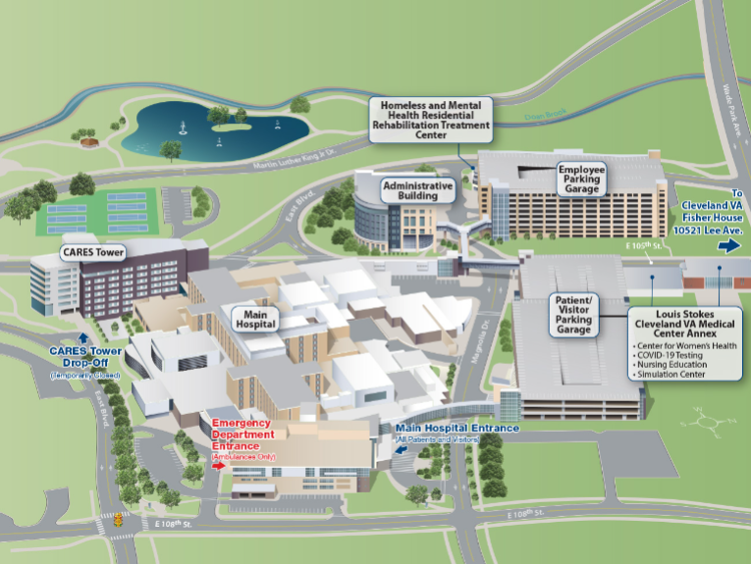
When arriving at the VA:
- Turn onto Magnolia Drive from E. 105th Street.
- Turn left into the patient/visitor parking garage.
- Once in the garage, make an immediate left and follow the aisle to the end.
- Turn right, and then turn left.
- You will see the VA Annex on your right. You may park in any spots at this time.
- Enter the Annex, there will be signs directing you to the meeting.
- Please call Sheryl Feeney’s cell if you need assistance - 216-570-4548

